WEB DESIGN
PROJECT REPORT

PROJECT TEAM
Student No. | Student Names
x19148275 | Conor Phelan
x19188251 | Severins Kudresovs

** Web Design Project **

** solution.works **

Overview

The idea of the project was to create a website for a handyman. Massive thanks to Vlad - our client. After he heard that Severin has to create a webpage for his project, he asked whether we could make one for him. He has provided an idea of what he wants to see on his website.

Nowadays there are thousands of domain posibilities, so we wanted to come up with something original. After consideration our focus fell on the domain name with extension .works as we felt that it would sound good in combination with carpenter/handyman/construction websites.

We proposed the domain name Solution.works. Firstly, the pronouciation of the website sounds like “solution that works”, which in our opinion is a great marketing trick. Vlad agreed with the idea and paid the bill for the domain on Euro DNS. From here work began.

Section 1: Design

Research / Investigation

We were looking at handyman responsive websites to understand the general idea on what has to be there on the page.
What we found out – there had to be a general profile of the man himself – what he does and what are his competences (plumbing, electricity, carpets, tiles etc.)
There has to be a contact page – so people can easily contact Vlad or leave their enquiries.
Majority of websites we looked at had little amount or no reviews at all, that is what we decided to improve in our website.
In addition, to show the credibility of reviews we decided to have a portfolio page consisting of pictures of the previous jobs Vlad has done.
Moreover, many websites we looked at focus on a single person, while we decided to write everything in 3rd person, so in the future Solution.works could potentially become a company and as Vlad often does the job with some colleagues, we thought that this could be relevant.
Finally, in our opinion poor websites where those that had all the information on a single page. Thanks to project description we had to make several pages, therefore we knew our website would have an advantage.

Requirements & Technical Approach

The plan was to present the idea and wireframe to our client and hear his preferences. When client said he is happy with the plan, we started with creating a project on Github. Github was perfect for us as could collaborate on the project simply by writing commands through Gitbash/Bash. We could add new code, pull and push the changes to our master branch and always have the same version of the code.

GitHub also helped to revert changes using reset/checkout commands. This was useful when we run at troubles and wanted to revert changes although the code was already saved.

Used Atom/Visual Studio Code for writing the code as it shows colour icons which makes it easier to visualise how the divs and the text would look like.

Sitemap & Wireframe
1.
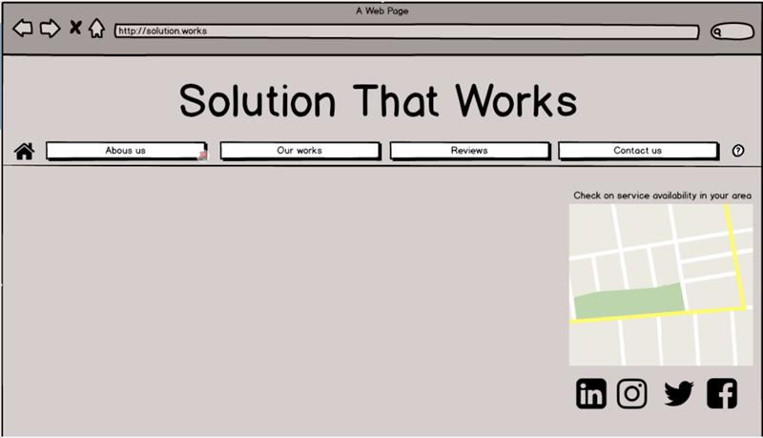
This was meant to be our main page. The navigation bar would appear on every page for easier navigation. Home sign would be a button bringing us to homepage.

2. The next page we sketched was the about page as it required some text and we wanted to see how we can make the text look nice and at the same time not be too much, so clients would read them rather than skip.
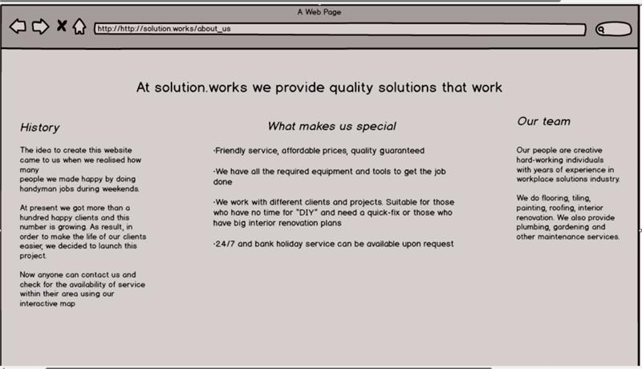
We agreed upon this design as it keeps all necessary description details on a single page. Here we have history, profile and some small facts that would make Vlad’s page special.

3. According to our initial plan, the contact page must have had links to social networks and a textbox for general enquiries in case if clients wanted to ask their question through email.

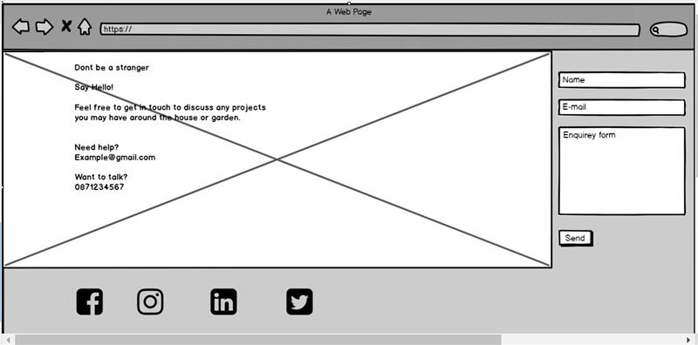
4. The review page even with fake temporary reviews would add strength and credibility to Vlad’s competence and skills. 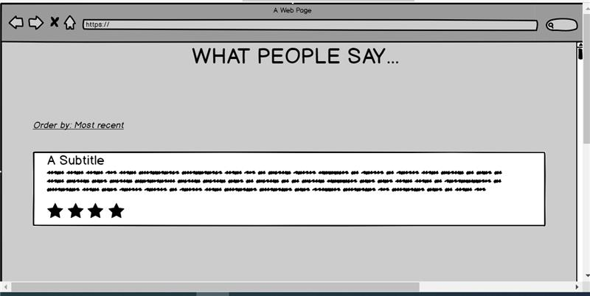

5. We did not require a wireframe example for our portfolio page as we were planning to simply load the page with the number of before/after jobs. We also had difficulties in terms of receiving material and photos from Vlad. Due to time limits, we had to use fake pictures for the moment.

Section 2: Development

To make the navigation bar look nice and stylish we decided to use code found on the Internet.( https://freefrontend.com/css-button-hover-effects/We searched for CSS button design/style and stopped on the one that changes the style of the button once you hover over it. The code was then implemented into our nav bar. By adding two divs to each button. These divs acted like borders that were moving once you hover mouse over it. It also would change the colour.

This gave us another idea to style word “that” in the header for it to become a black dot once you hover over it. This worked partially well, as the word that started moving also when you refresh the page. Managed to debug it by running the code through validator. Realised that was best to use SPAN instead of <h3> elements.

Main page consisted of icons that explain what the company does. Icons were taken from(www.icons8.com) and as per website instruction link to their website was left on the page. We used copyright sign for that link.
Separate folders were created for all assets and icons individually.

The whole idea was to create a website that would be understandable for all kinds of auditory. Therefore, the design is simple enough for an elderly person to navigate.

Validation & Errors

** This section should look at validation of the website (HTML & CSS), were you able to validate the website, were there any errors and if so, how did you go about fixing them.

Please make sure to include a screenshot(s) of your validation reports here **
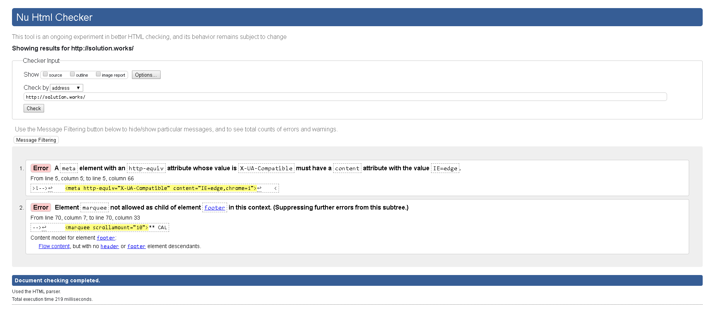

Section 3: Deployment

The deployment was divided in 2 sections. The registration of the domain and deployment on Amazon s3 bucket. The domain was purchased for 1 year with possibility of extension. The bill was paid by the client.
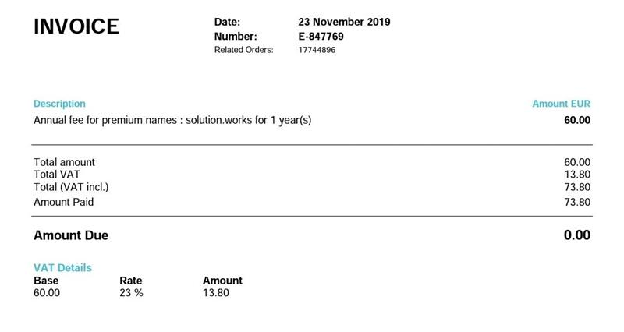
We decided to deploy it on Amazon as it was fast and convenient option. What was required is to add public access and bucket policy.

Linking our DNS domain with Amazon bucket was a bit challenging. After conducting some research, we found out that we had to find the hostname of our bucket and type ping “hostname” in command prompt to get the Ip address, this Ip address was added into our DNZ zone on the DNS management page.
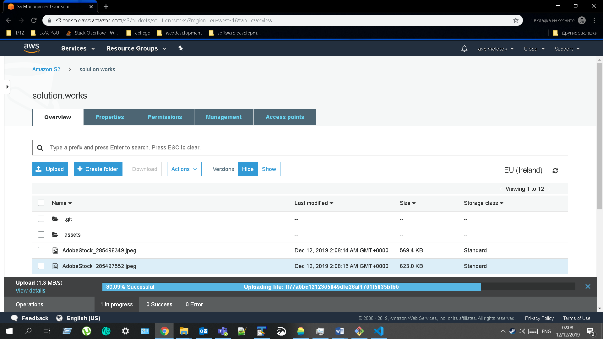

Section 4: User Testing

Severin’s colleagues at work looked at the website. In general people liked, there were some suggestions regarding color schemes which were later considered and implemented. It worked well and the website was more appreciated also by the client Vlad. He is currently gathering pictures as he wants to make the slideshow of his works.

Section 5: Project Team

Severin was organizing the project and negotiating with the client. Receiving feedback and sharing client preferrences with Conor. Conor was looking at similar websites trying to find some optimal design for our website at the same time trying to sketch something up in Balsamiq.

Severin created the depository on github and added Conor to it so they both could collaborate on a single file using git pull / git add / git commit / git push commands.

Since Severin came up with the idea of the domain name and subsequently purchased it, he also took the task to do a research on deployment and subsequently deployed the website on Amazon s3 bucket.

After this we divided pages. Severin was working on the navigation bar and header, on index, about us and maps pages. Conor was tasked with testimonials, contact us and portfolio pages, where he implemented javascript making pictures appear in slideshow.

Conor also created accounts with adobe stock and pexels in order to find and licence the images used on the website. Subsequently, when we had the structure and content, Conor continued working on responsiveness, while Severin was finalising the styling in CSS reflecting user feedbacks.

Validator discovered an issue around meta element and marque.

Section 6: Conclusion

Initially more than 3 weeks of time was lost due to groups allocation. We were initially placed in groups of 2 instead of 3, Severin with one student and Conor with another. As our ex-partners were in touch with us and promising us to start working on a project ASAP, we had no clue that they will later drop out. Because of that precious time that we could have spent on work was lost.

Then after 3 weeks, we (Severin and Conor) were placed in a new group and we had to come up with new idea and start working on the project. The new wireframe had to be completed (Severin had wireframe done based on the idea of his ex-teammate). Only after that we started doing research on deployment and started planning the website.

As we were only 2 people again, the burden was too high for us to cope with in such short period of time and due to these constraints, we haven’t fully finished the responsiveness and JavaScript.

We personally think the website looks good, however we are not fully happy how everything went, as the responsiveness could’ve been better, but big amendments to the code would’ve been made. We both tried to make the navigation bar responsive changing into dropdown box, however after hours of typing we decided to spend time on report, commenting and structure formatting.

The website is definitely not finished now and, as this is a real project for the real client, the work on it will continue also in the future.

Section 7: References / Appendix
Icons for index page taken from - https://www.icons8.com/

“Fancy border button”, Tobias Reich - https://freefrontend.com/css-button-hover-effects/Colour palettes https://colorhunt.co/
Copyright sign https://unicode-table.com/en/
Plumberpic - https://pixabay.com/vectors/plumber-repair-mechanic-plumbing-35611/

Handyman website examples:

https://www.responsivemiracle.com/best-responsive-handyman-website-templates/

https://www.handymanforaday.ie/

https://www.thehandymandublin.com/

